 | Supplementary Regulations
European Championship Motocross/Snowcross

CATEGORIES
EMX65 | EMX85 | EMX125 | EMX250 | EMX2T | EMXOpen | EMXQuad | Women | SNX
x | x | ☐ | ☐ | x | ☐ | ☐ | ☐ | ☐

IMN: | 223/21 | 716/01
Date: | 15-16.07.2023
FMNR: | ACCR
Venue: | Loket
Name circuit |  |  | Loketské serpentiny
Organiser/Club |  |  | Automotoklub Loket v AČR

ACCESS
Nearest Airport | Vaclav Havel Airport Prague | at | 135 | Km from the circuit
Motorway | E48 | exit | Loket
National road | 9
Nearest Town | Loket
Direction | West | at | 2 | Km from the circuit

NEAREST HOSPITAL
Name | Sokolov | at | 8 | Km from the circuit
street | Slovenská 545
City | Sokolov
E-mail | (not available)
Telnr | +420 352 520 111

STARTING NUMBERS
Combined INFRONT events |  | INFRONT Sport Office | sportoffice@mxgp.com
Not Combined events |  | FIM Europe Start numbers | peter.hansenmx@gmail.com
All riders will receive from the FIM Europe Motocross Commission a permanent starting number to be used for the entire season. Changing during the season without prior written approval of the FIM Europe Motocross Commission/ Infront Moto Racing is not possible :
E-mail Infront | sportoffice@mxgp.com
Web FIME  E-mail FIM E | http://www.fim-europe.com/motocross-snowcross/  peter.hansenmx@gmail.com

OFFICIALS
 | NAME | Federation. | Licence nr
FIM E Jury President
FIM E Delegate | Andrea Barbieri | FMI | 4728
FIM E Steward | Antonio Alia | RFME
FMNR Jury Member | Tomáš Honzík | ACCR | 2022-OFF-200015587
FIM E Race Director | Tomas Pavlovcik | SMF
Secretary of the Jury | Jaroslav Piela | ACCR
Clerk of the Course | Zdeněk Dvořák | ACCR | 2022-OFF-200015586
Chief Technical Steward | Jiří Chmel | ACCR | 2023-OFF-790016653
Chief Timekeeper | Infront Timekeeping
Environmental Steward | Alexandra Dašková | ACCR | 2021-OFF-620014983
Chief Medical Officer | Marcela Maternová | ACCR | 2022-OFF-720015913
Press Officer | Tereza Piela | ACCR
Paddock Official | Jaroslav Faflík | ACCR
The meeting will be organized in conformity with the FIM Europe Sporting Code, the FIM E MX rules, CMS Regulations, the general rules of the ACCR (FMNR), where applicable, and these Supplementary Regulations which have been duly examined and approved by ACCR (FMNR).

- ORGANIZER
Name | Automotoklub Loket v AČR
Street | Na Vyhlídce 592
City | Loket
Phone | +420 352 684 023
E-mail | dvorak.amk.loket@gmail.com
Web Site | www.loketmx.com
Minimum width | 6 m

- SECRETARIAT of the MEETING
Location | Automotoklub Loket v AČR
 | Na Vyhlídce 592
 | Loket
Phone | +420 352 684 023
E-mail | dvorak.amk.loket@gmail.com

- ENTRIES
Entry Forms duly approved by the participants must be send to :
Infront Moto Racing online entry system
Phone
E-mail | sportoffice@mxgp.com
Not later than |  | (30 days before the meeting)

- WELCOME CENTER
Location | Near the circuit - GPS: 50º12'21.778"N, 12º45'59.778"E
Phone
E-mail | info@loketmx.com
Open on:
Day | Date | From | To
Thursday | 13.07. | 14:00 | 19:00
Friday | 14.07. | 08:00 | 19:00
Saturday | 15.07. | 08:00 | 19:00
Sunday | 16.07. | 08:00 | 13:00

- CIRCUIT
Name | Loketské serpentiny
Street | Na Vyhlídce 592
City | Loket
GPS Coordinates | 50º11'44.64"N, 12º45'30.54"E
Length of the track | 1586 m
Minimum width | 6 m
A drawing of the circuit is attached to these regulations
The race office must be equipped with a high speed internet connection over the whole meeting

- TIMEKEEPING
Name
E-mail | timekeeping@mxgp.com
Web Site
The maximum fee for Transponders rent is 100,-€.
The fee has to be payed back after return of the Transponder.

7 - CIRCUIT CONTROL
Meeting point: At the starting grid.
See attached Time Schedule.

8 - MEETING WITH THE ORGANIZERS
Venue: Jury room.
See attached Time Schedule.

9 - TECHNICAL CONTROL AND VERFICATIONS
Venue: The Technical control post.
See attached Time Schedule.

10 - JURY MEETINGS
Venue: The Jury room.
See attached Time Schedule.
The jury room is equipped with a high speed internet connection over the whole meeting.

11 – FUEL
In according with FIM specifications.

12 – INSURANCE
The organizer has contacted a third party insurance in according with Art. 110.1 of the FIM Europe Sporting Code. This insurance includes a guarantee of the minimum amount as stipulated by the FIM Europe Management Council. The Insurance comes in effect 2 days before the first practise and ends 2 days after the meeting.
The organizer disclaims all responsibility for damage to a motorcycle, its accessories and components arising out of an accident, fire or other incident.

13 - PROTEST AND APPEALS
Any person or group of persons (rider, entrant, manufacturer, official, etc.), recognized by the FIM and concerned by a decision taken under the authority of the FIM Europe, may ask for redress for the consequences of that decision.
Protest must be lodged according to the FIM Europe Disciplinary and Arbitration Code and the Supplementary Regulations and be accompanied by a fee of € 350,00 or equivalent amount in local currency, returnable if the protest is justified.
In general, protests against eligibility of a rider entered, must be made before the start of the official practice.
Protests against results must be presented to the International Jury within 30 minutes following the publishing of the results.
An appeal can be made to the FIM Europe Disciplinary Commission against a decision of the International Jury.
In case of FIM combined races an appeal can be made to the FIM Stewards Panel against a decision of the Race Direction.
Protest entailing a fuel control: See FIM Europe MX rules.

14 - PRICE-GIVING CEREMONY
Venue of the prize-giving ceremony : Starting gate
See attached Timetable.

The first three riders are invited to attend the prize-giving ceremony.
Additional other riders can be invited by Infront or the organizer. Riders might also be invited for a Press Conference.
If invited attendance to the prize giving ceremony or press conference is compulsory.

15 - INTERPRETATION OF THE SUPPLEMENTARY REGULATIONS
The interpretation of this regulations rests entirely with the Jury or Race Direction. In case of dispute, regarding the interpretation or if there is any difference between the two official texts, the English text will prevail.

Place and date: Loket, 28.04.2023

The Clerk of the Course: Zdeněk Dvořák

Approved by FMNR: ACCR

Approved by FIM Europe : Andrea Barbieri 04-05.2023 Date :

Attachmend:
Page 1: A map of the region, including the venue of the circuit
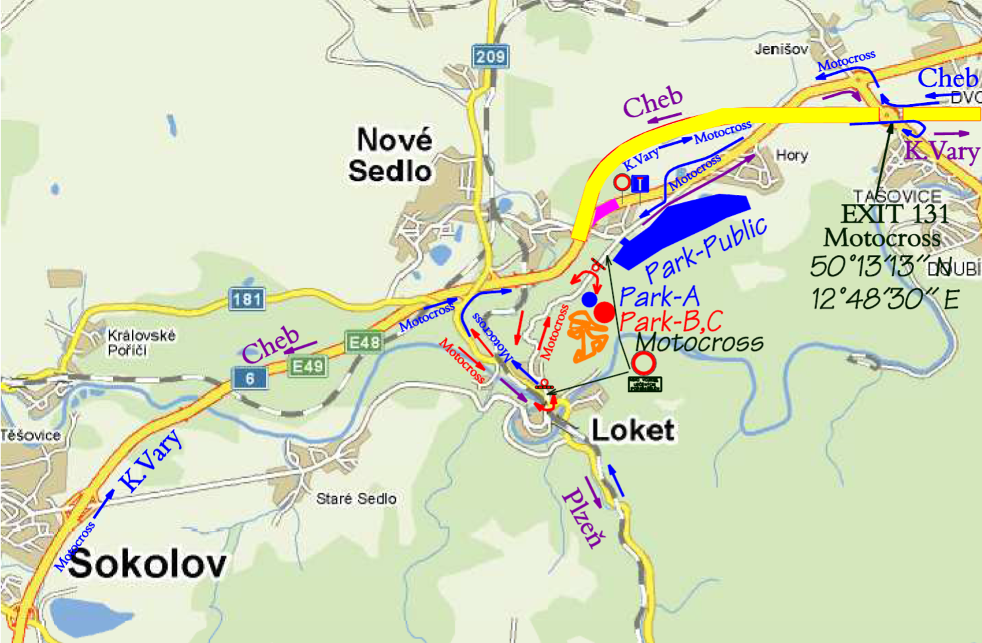

Page 2: Time Schedule

Page 3: Drawing of the circuit
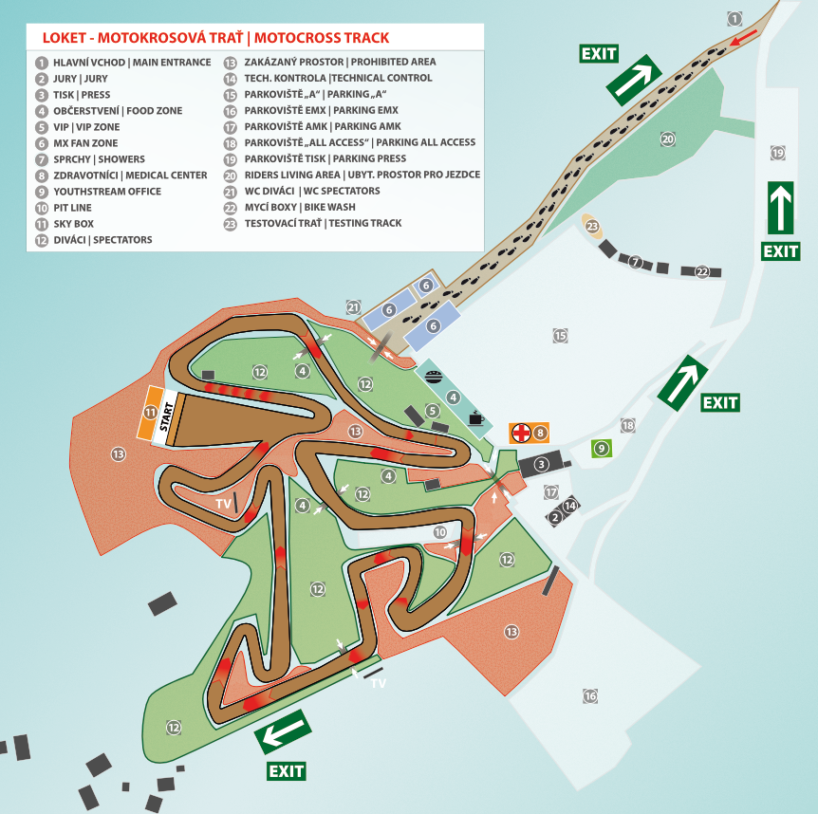
Page 4: …
Page 5: …

